Submission Format

All “P” criteria must be successfully completed to pass the module. The submission is in the form of an individual written report. This should be written in a concise, formal business style, using 1.5 spacing and font size 12. You are required to make use of headings, paragraphs and subsections, as appropriate, and all the work must be your own or supported with research and referenced using the Harvard referencing system. Provide a bibliography using the Harvard referencing system should you wish to include the work of others.

Unit Learning Outcomes

LO1 Examine the application of management techniques, cultural and leadership aspects to engineering organisations.

LO2 Explore the role of risk and quality management in improving performance in engineering organisations.

LO3 Investigate the theories and tools of project and operations management when managing activities and optimising resource allocation.

LO4 Perform activities that improve current management strategies within an engineering organisation.

Assignment Brief and Guidance

Scenario
Having just completed your qualification, you have been promoted to cell production leader at an established manufacturing firm, Super Beam Technologies (SBT). SBT supplies headlight assemblies to the automotive industry. The company has twenty five employees, ten of whom have been in the company for over 8 years. The company provides injection moulding of casings and assembly of components. Some product design services can also be provided on request.

The company is looking to expand its operations and therefore much change will be required of the workforce. New customers and products will require a heavy emphasis on quality improvement projects and the car manufacturers will issue severe penalties for defective quality. For the car manufacture reputation and customer safety is paramount. The headlight is critical to the car and passenger safety providing, daytime running light, turn indicator bulb, driving light and full beam feature. Consequently the long-standing Operations Manager has asked you, as the newest qualified member of staff, to produce two reports on the engineering management techniques applicable in the modern day automotive component supply industry. The manager requires you to follow specific guidelines of interest to the company.

*

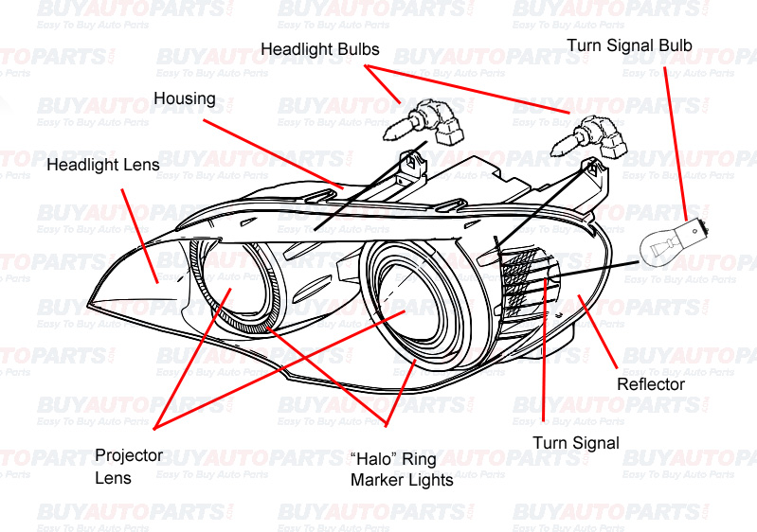
Report 1: Existing operations in the context of current approaches to Risk and Improvement
Here you are required to write a report examining operational management in light of culture and preventative towards quality management in the general context and then relate to the case study in question
Guidelines (note: the more criteria covered correctly the higher the grade achieved)

- Examine the following leadership/management styles and how they influence organisational culture and contribute towards change:
- Autocratic Leadership
- Laissez-Faire Leadership
- Transformative Leadership
- Participant Leadership
- Transactional Leadership

- Choose two management/leadership approaches from the above that you would recommend for the company in question. Justify choice (Consider influence on organisational culture and communication practices).

- Provide recommendations for the most efficient application of the above in the automotive component manufacturer.

- Describe the role and impact of DFMEA and PFMEA in automotive component manufacture.

- Explain how risk and quality management strategies in the automotive industry encourage continuous improvement.

- The following is perceived as an efficient and effective risk management process: Step 1: Identify the Risk. Step 2: Analyse the risk. Step 3: Evaluate or Rank the Risk. You Step 4: Treat the Risk Step 5: Monitor and Review the risk. Recommend this process with justification to the automotive component company

Report 2: Project and operations management & current management strategies
Here you are required to write a report project and operation management in light of tools, theories and best practice. Relate to the case study provided for all points except point (6) where you may use a another case study to support your work.
Guidelines (note: the more criteria covered correctly the higher the grade achieved)

- Identify the following with diagrams
  - Gantt charts

  - Flow charts

  - Critical path analysis

- Analyse the effectiveness of the tools above regarding a project to design a new component

- Analyse the relative merits of theories and tools of project and operations management

- Define Lean and Six Sigma

- Explore the activities involved in the above

- Provide full analysis of the management processes in an organisation of your choice and provide justified recommendations for improvements


Learning Outcomes and Assessment Criteria

 |  | Learning Outcome |  |  | Pass |  |  | Merit |  |  | Distinction
 |  | LO1 Examine the |  |  | P1 Explain management |  |  | M1 Justify different |  |  | D1 Propose
 |  | application of |  |  | and leadership theories |  |  | management techniques |  |  | recommendations for the
 |  | management techniques, |  |  | and techniques used |  |  | with emphasis on cultural |  |  | most efficient application
 |  | cultural and leadership |  |  | within engineering |  |  | and leadership aspects |  |  | of management
 |  | aspects to engineering |  |  | organisations. |  |  | and their applications to |  |  | techniques.
 |  | organisations. |  |  |  |  |  | engineering
 |  |  |  |  |  |  |  | organisations.
 |  | LO2 Explore the role of |  |  | P2 Describe the role and |  |  | M2 Explain how risk and |  |  | D2 Provide supported
 |  | risk and quality |  |  | importance of risk and |  |  | quality management |  |  | and justified
 |  | management in |  |  | quality management |  |  | strategies encourage |  |  | recommendations for the
 |  | improving performance |  |  | processes and their |  |  | performance |  |  | most efficient and
 |  | in engineering |  |  | impact on engineering |  |  | improvements within |  |  | effective risk and quality
 |  | organisations. |  |  | organisations. |  |  | engineering |  |  | management practices.
 |  |  |  |  |  |  |  | organisations.
 |  | LO3 Investigate the |  |  | P3 Identify project and |  |  | M3 Analyse the most |  |  | D3 Analyse the relative
 |  | theories and tools of |  |  | operations management |  |  | effective project and |  |  | merits of theories and
 |  | project and operations |  |  | tools used when |  |  | operations management |  |  | tools of project and
 |  | management when |  |  | managing activities and |  |  | tools used when |  |  | operations management
 |  | managing activities and |  |  | resources within the |  |  | managing activities and |  |  | with a focus on their
 |  | optimising resource |  |  | engineering industry. |  |  | optimising resource |  |  | relevance when
 |  | allocation. |  |  |  |  |  | allocation. |  |  | managing activities and
 |  |  |  |  |  |  |  |  |  |  | optimising resource
 |  |  |  |  |  |  |  |  |  |  | allocation.
 |  | LO4 Perform activities |  |  | P4 Define the range of |  |  | M4 Explore activities that |  |  | D4 Conduct a full analysis
 |  | that improve current |  |  | processes available to |  |  | will improve |  |  | of the management
 |  | management strategies |  |  | improve management |  |  | management strategies |  |  | processes within an
 |  | within an engineering |  |  | processes within an |  |  | within an engineering |  |  | engineering organisation
 |  | organisation. |  |  | engineering organisation. |  |  | organisation. |  |  | (or case study) and make
 |  |  |  |  |  |  |  |  |  |  | fully justified
 |  |  |  |  |  |  |  |  |  |  | recommendations for
 |  |  |  |  |  |  |  |  |  |  | improvements to the
 |  |  |  |  |  |  |  |  |  |  | management strategies.

